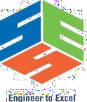
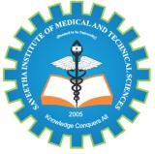
SIMATSENGINEERING

Saveetha Institute of Medical and Technical Sciences Chennai- 602105

Student Name: T.Gnaneswari Reg. No.: 192372183
Course Code: CSA1305 Slot: D
Course Name: INTERNET PROGRAMMING
Course Faculty: Dr. D.Sudhagaran

Project Title: Stuudent Skills Development management system
Photographs: (2 photographs –Module photo contribution module work in the project and presentation image)
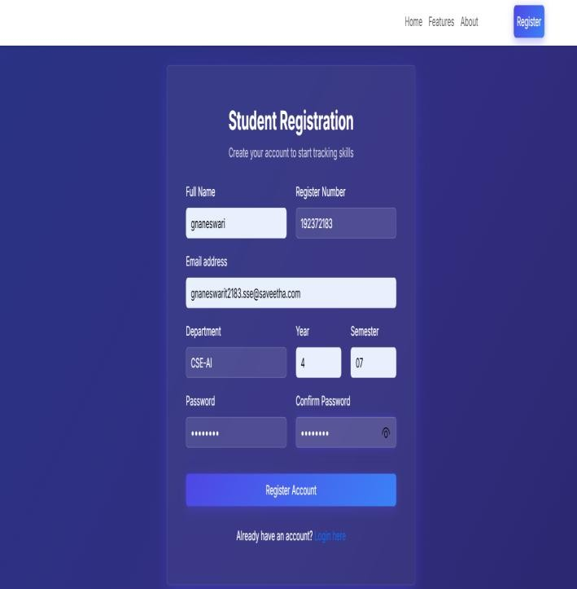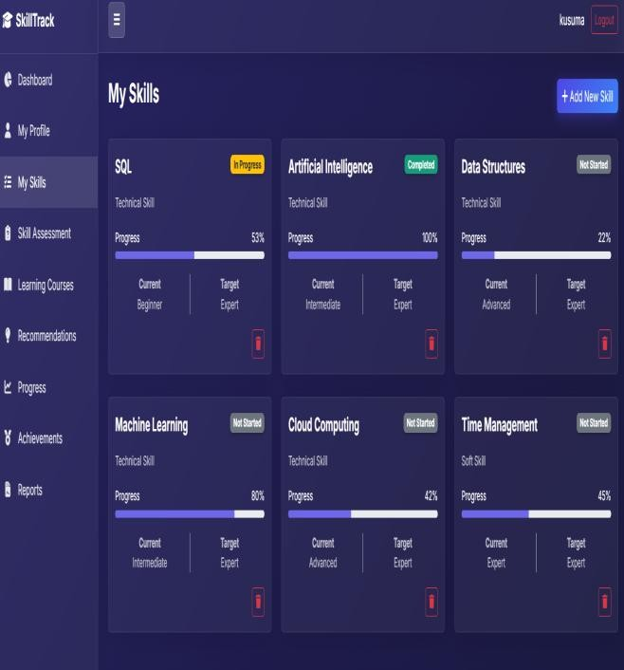
Output
Project Description: (here you write what you did in this project (contribution) including Model Description
The **Student Skills Development Management System** is a comprehensive, web-based platform designed to bridge the gap between academic learning and industry requirements. Its primary objective is to empower students to systematically identify, track, and enhance their technical and soft skills to align with their desired career goals, such as Software Development, Data Science, or AI Engineering. By providing a centralized, interactive dashboard, the system allows students to take full ownership of their professional development. Students can maintain personalized profiles, log their progress in various learning courses, and visualize their growing skill sets through intuitive charts and analytics.To keep students engaged and motivated, the system features built-in skill assessments across multiple difficulty levels, rewarding successful completions with gamified achievements and badges. Additionally, it can generate detailed, printable reports that summarize a student's entire skill profile, making it a highly valuable tool for placement preparations, resume building, and academic review by administrators. Built on a modern and scalable technology stack, the backend is powered by Python and FastAPI to ensure rapid, secure API responses, while MongoDB serves as a flexible NoSQL database for managing complex student profiles and analytics. The frontend is crafted using HTML, Vanilla CSS, Bootstrap, and JavaScript.

T.Gnaneswari DR.D.Sudhagaran
Student Signature Guide Sign

